Microsoft Dynamics 365 Introduction

The right CRM will help you to maximise revenue by enhancing marketing and sales processes to deliver operational excellence and create a more engaging customer experience.
In small to medium businesses, time and resources must be used effectively. Automating and centralising customer data and interactions means you can focus on what’s more important. Properly customised and implemented Dynamics 365 will enable you to identify opportunities for growth, increase revenue, improve productivity and maintain the customer relationships that matter.

Microsoft Dynamics 365 – Applications to Drive Growth Across Your Organisation
Dynamics 365 offers a proven, customisable, flexible CRM solution, designed to meet the requirements of SMEs. You can choose from a stand-alone application for a specific line of business (such as Sales or Marketing) or use multiple CRM tools that work together as a powerful integrated solution.
Dynamics 365 integrates seamlessly with Microsoft 365. Microsoft Teams integration allows you to speed up the flow of work, enabling anyone within your organisation to view and collaborate on Dynamics 365 records, from within the flow of work with Teams.

Dynamics 365  Marketing  Dynamics 365 Marketing deliver extensive marketing automation capabilities, to drive personalisation and deliver tailored customer journeys to improve engagement and results. |  | Dynamics 365  Sales  Microsoft Dynamics 365 offers a powerful, access-anywhere, collaborative sales team solution that increases focus, insight and performance to achieve better results. |  | Dynamics 365  Customer Service  Provides an agile customer service solution that will increase productivity, reduce costs help identify sales opportunities and improve the customer experience.

Dynamics 365 Marketing
Improve your customers' journey

Generate multi-channel marketing campaigns, nurture sales-ready leads, and align your sales and marketing teams with planning and tracking tools that integrate with your existing apps and services.

Foster Leads
- Run multi-channel campaigns featuring email marketing, web content, and events.
- Target matched audiences based on LinkedIn interactions using Dynamics 365 Connector for LinkedIn Lead Gen Forms.
- Personalise the buyer experience by customising customer journeys based on user engagement.

Make Better Decisions
- Gain insights into your brand reputation and market through real-time data analysis.
- Prioritise leads using multiple lead scoring models.
- Build custom dashboards to analyse the data that matters most to your business.

Adapt Quickly
- Automate processes for better service engagement experiences.
- Use artificial intelligence to guide your business decisions and drive innovation.
- Rely on the Microsoft cloud platform to reduce operating costs and simplify deployment across your infrastructure.

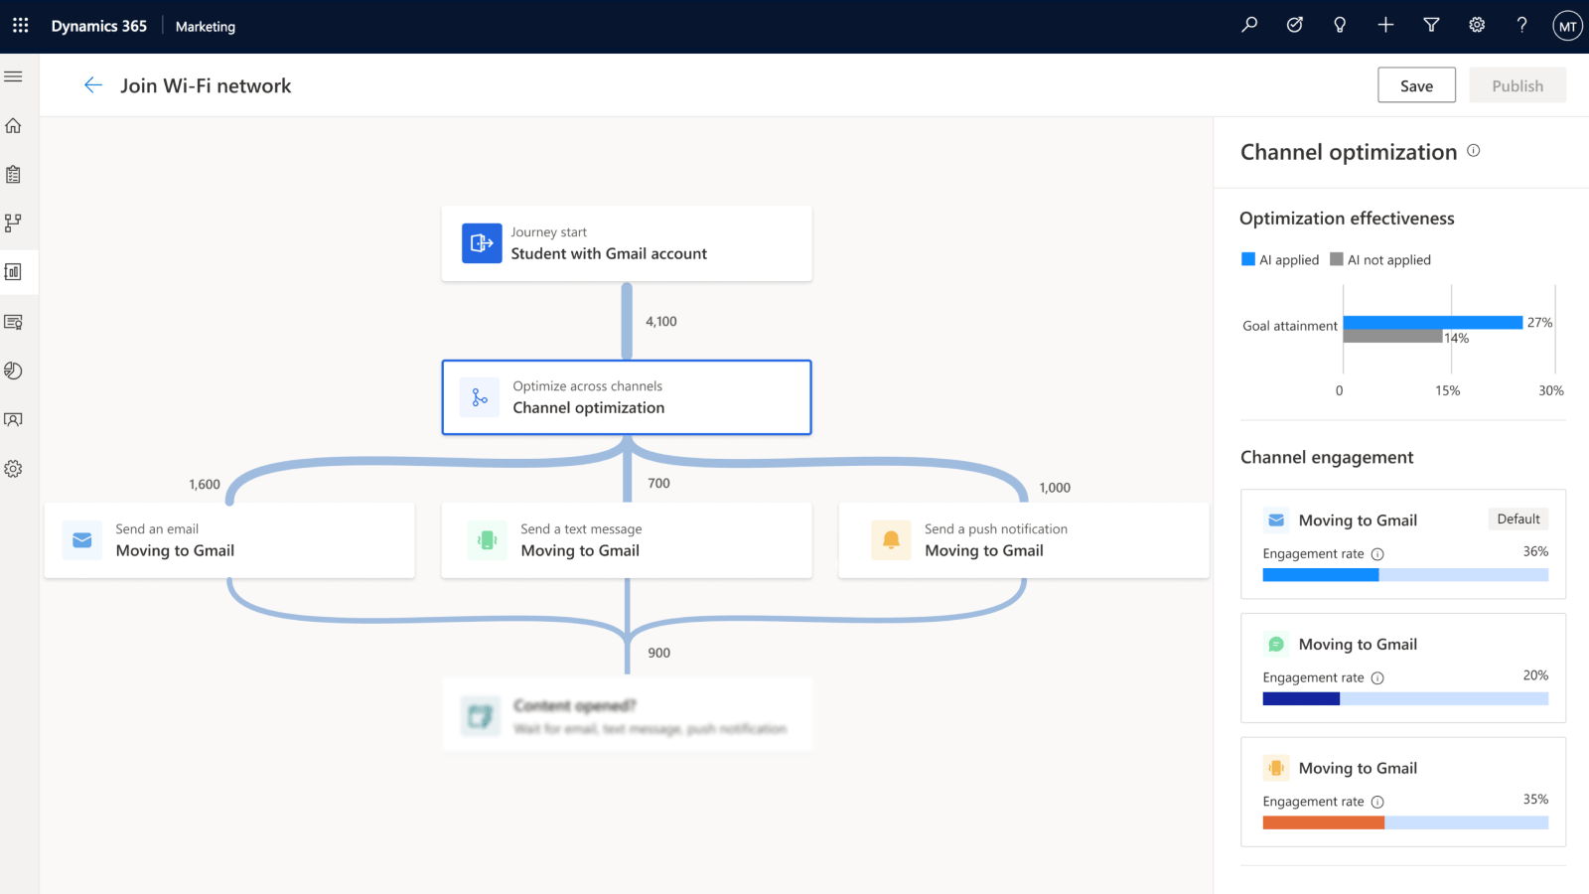 | 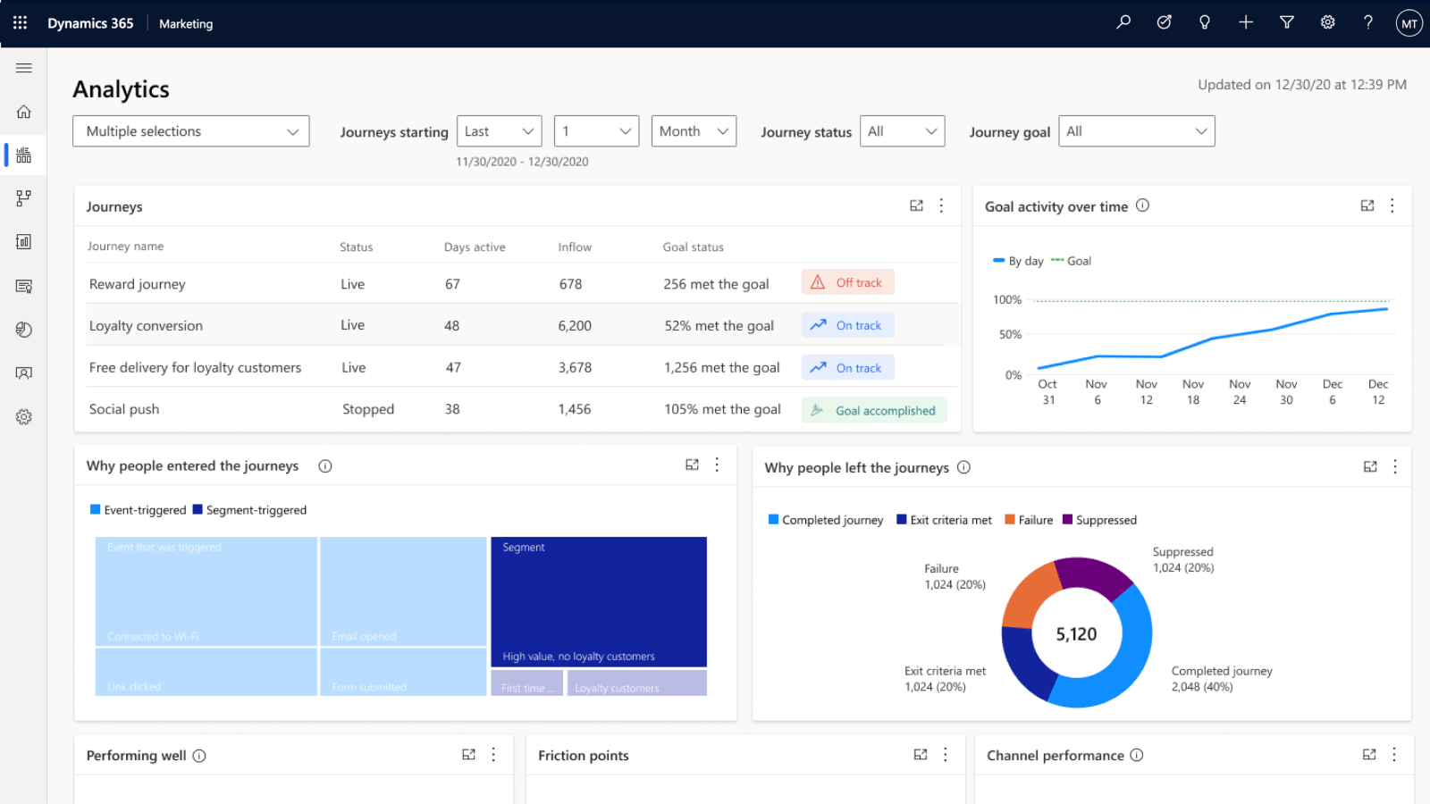
Suggested Image 1  Personalised, real-time customer engagement journeys | Suggested Image 2  Real-time KPIs and dashboards to track effectiveness and activate AI-driven content

Dynamics 365 Sales

Empower personal engagement with your customers

Go beyond sales force automation to better understand customer needs, engage more effectively, and win more deals. Sell smarter with embedded insights, foster relationships, boost productivity, accelerate sales performance, and innovate with a modern and adaptable platform. Use AI capabilities to track customer relationships and automate sales execution with contextual prompts that drive sales strategy.

Grow Business
- Improve win rate with a dynamic, event-driven sales process.
- Build pipeline with high-quality leads and prospects from a variety of sources.
- Measure the past and identify leading indicators for the future.

Stay Focused
- Find the right prospects and customers.
- Always know the next best action to move relationships forward.
- Build a high-performing sales team.

Win Faster
- Engage and collaborate around strategic deals.
- Align to the buyer’s journey to deliver personalised engagement.
- Work anytime, anywhere on any device

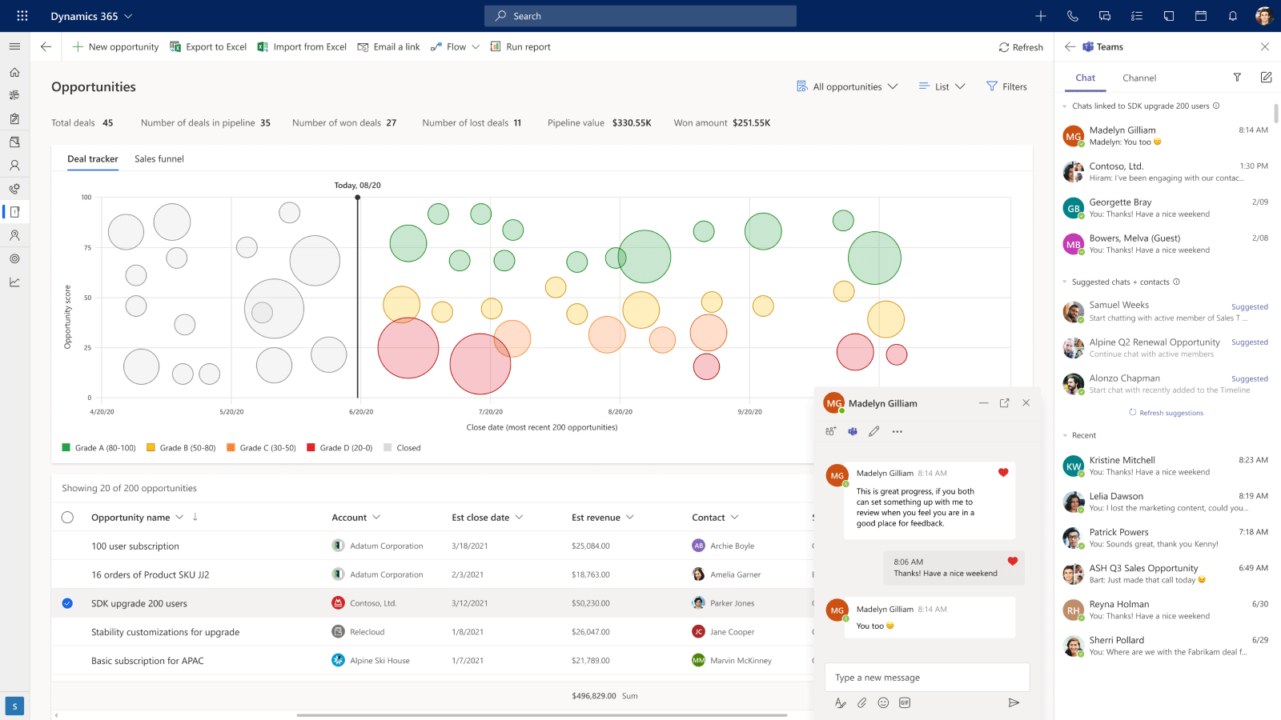 | 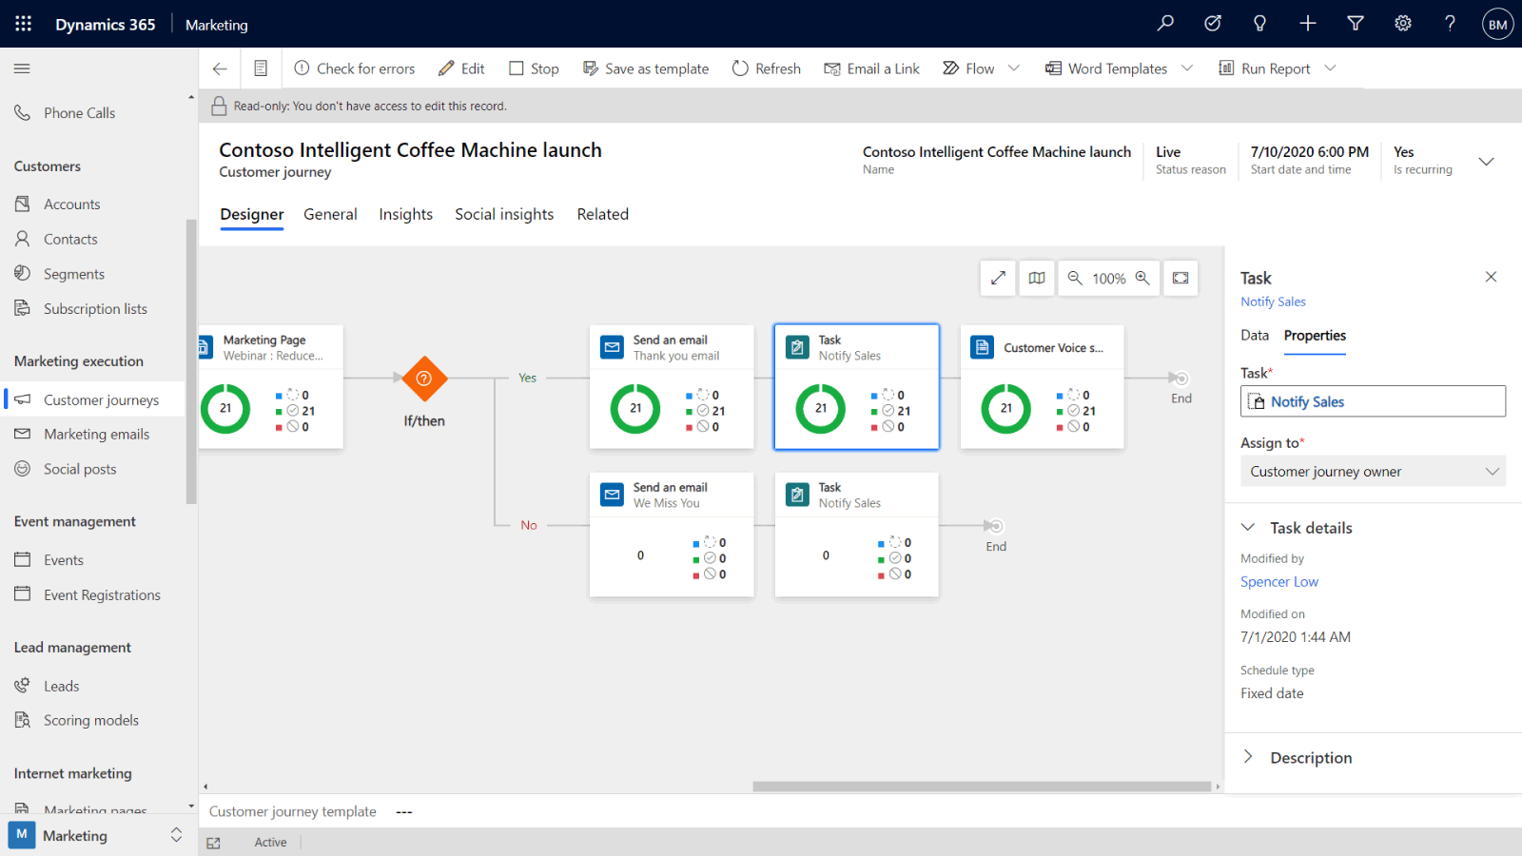
Suggested Image 1  Intuitive, personalised workspaces to work quickly and built-in productivity and collaboration from Microsoft 365 and Teams | Suggested Image 2  Minimise routine tasks, automate and prioritise daily activities and work seamlessly with your everyday apps

Dynamics 365 Customer Service

Effortless service through any channel

Deliver guided, intelligent, service and support on any channel with a unique ability to work with your existing systems. Empower customers and agents with the tools they need to ensure quick and accurate resolution, every time.

Improve Engagement
- Let customers connect quickly and easily through multi-channel service options.
- Use the artificial intelligence of service bots to increase service availability and free your agents for more high-value interactions.
- Resolve issues quickly using data analysis and predictive care.

Personalise your Customer Interaction
- Deliver value with every interaction with a complete customer view.
- Guide agents’ actions toward optimal outcomes using intelligent automation.
- Create upsell or cross-sell opportunities using contextual customer data.

Streamline your Customer Service
- Improve service based on survey feedback, discussion forums, and social listening.
- Onboard new agents quickly with in-app learning options.
- Optimise your service staff by allocating resources based on service trends that you can monitor in real time.

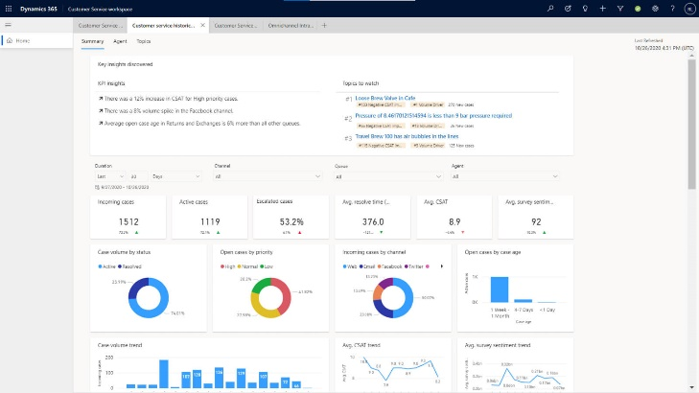 | 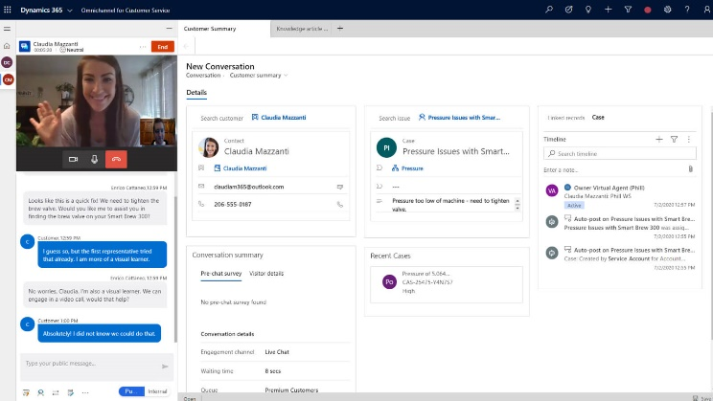
Suggested Image 1  Powerful dashboards and analytics to improve customer experiences and team performance | Suggested Image 2  Deliver multi-channel service options to engage with your customers

